

**Product Dissection for Zomato**

**Company Overview:**

Zomato, founded in 2008 by Deepinder Goyal and Pankaj Chaddah in India, has redefined the way people discover, order, and experience food. What began as a simple restaurant discovery platform has now evolved into a global food services company that spans online ordering, restaurant reviews, table reservations, and even food delivery. With its user-friendly interface, diverse offerings, and focus on customer convenience, Zomato has grown into one of the leading platforms in the food tech and delivery industry, connecting millions of users with restaurants and delivery partners across multiple countries.

**Product Dissection and Real-World Problems Solved by Zomato:**

Zomato, a pioneer in the food delivery ecosystem, has effectively tackled real-world challenges surrounding food discovery, accessibility, and convenience through its innovative product features. By enabling users to search and explore restaurants based on cuisine, ratings, price, or location, Zomato provides a solution to the age-old problem of “Where and what should I eat?” This discovery mechanism, supported by ratings, photos, and reviews, bridges the gap between diners and restaurants by offering reliable insights that guide decision-making.

Zomato’s online ordering and delivery services address the challenges of accessibility and time constraints. Users can browse menus, place orders, and track deliveries in real time, offering a seamless alternative to traditional dining. This solves the real-world problem of busy lifestyles, limited cooking time, or geographical restrictions. Additionally, features like table reservations streamline the dining-out experience by removing the hassle of waiting in queues, ensuring smoother customer experiences at popular restaurants.

Beyond customer convenience, Zomato also provides innovative solutions for restaurants and delivery partners. For restaurants, the platform acts as a powerful marketing and customer acquisition tool, helping them reach a broader audience. For delivery partners, Zomato generates employment opportunities by integrating them into its logistics ecosystem.

In conclusion, Zomato’s product design has successfully addressed key real-world problems by connecting people with food in faster, smarter, and more efficient ways. Through its combination of restaurant discovery, user reviews, food delivery, and reservations, Zomato caters to the evolving needs of modern society. Its diverse features not only enhance user convenience but also strengthen the food industry ecosystem, making it a trusted companion for millions of users worldwide.

**Case Study: Real-World Problems and Zomato's Innovative Solutions**

Zomato, a leading food delivery and restaurant discovery platform, has transformed the way people access food services while addressing key real-world challenges through its innovative product features. By identifying everyday problems and leveraging technology, Zomato has positioned itself as a solution-driven platform that enhances convenience, supports businesses, and improves dining experiences.

**Problem 1: Difficulty in Discovering Restaurants**

**Real-World Challenge:** Earlier, people relied on word-of-mouth, advertisements, or random visits to discover new restaurants. This often led to limited choices, inconsistent experiences, and missed opportunities to explore new cuisines.

**Zomato's Solution:**

Zomato provides a comprehensive restaurant discovery platform with detailed menus, photos, user reviews, ratings, and filters (cuisine, cost, location). This solves the problem by giving users transparent information to make informed decisions about where and what to eat.

**Problem 2: Long Waiting Times & Accessibility Issues**

**Real-World Challenge:**

Dining out often involved long waiting times, travel, and accessibility concerns, especially for people in busy cities or remote areas.

**Zomato's Solution:**

Through its **food delivery service**, Zomato enables users to order meals directly from restaurants and have them delivered to their doorstep. This innovation addresses the issue of time constraints, accessibility, and convenience, ensuring users can enjoy quality food without stepping out.

**Problem 3: Trust & Transparency in Quality**

**Real-World Challenge:** Customers were often unsure about the hygiene, quality, and authenticity of restaurants. Similarly, restaurants faced challenges in building credibility and attracting new customers.

**Zomato's Solution:**

Zomato introduced **user-generated ratings, reviews, and hygiene ratings**, providing a transparent view of restaurant quality. For restaurants, this builds trust and credibility, while for users, it reduces the uncertainty of trying new places.

**Problem 4: Supporting Local Restaurants & Small Businesses**

**Real-World Challenge:** Many small and local restaurants lacked visibility and struggled to reach a wider audience in a competitive market dominated by big brands.

**Zomato's Solution:**

Zomato provides restaurants with a digital presence and access to millions of users. With tools like promotions, advertisements, and loyalty programs, small restaurants can grow their customer base and compete on a level playing field.

**Problem 5: Payment & Transaction Barriers**

**Real-World Challenge:** Managing cash payments, exact change, and trust issues in transactions used to be a hassle for both customers and restaurants.

**Zomato's Solution:**  
Zomato integrated **secure digital payments (Zomato Pay, UPI, cards, wallets)** that made transactions seamless, cashless, and more reliable. This eliminates friction in the food ordering and dining process.

**Conclusion:**

Zomato’s journey from a restaurant listing platform to a comprehensive food-tech leader highlights its ability to solve real-world problems with innovation. By improving restaurant discovery, enabling convenient delivery, building transparency, supporting small businesses, and offering seamless payments, Zomato has transformed the way people experience food services. This case study demonstrates how Zomato’s user-focused approach continues to shape the food and hospitality ecosystem globally.

**Top Features of Zomato:**

1. **Restaurant Profiles:** Zomato provides detailed restaurant profiles, including menus, photos, operating hours, contact details, pricing, and user ratings. This helps users gain a complete understanding of a restaurant before making a decision.
2. **Food Delivery & Takeaway:** A key feature of Zomato is its online food delivery and takeaway service. Users can browse menus, place orders, and have food delivered to their doorstep or schedule a pickup, ensuring maximum convenience.
3. **Reviews and Ratings:**  Engagement is built through customer feedback. Users can share their experiences by writing reviews, uploading food photos, and rating restaurants. This transparency builds trust and helps others make informed choices.

1. **Search and Filters:** Zomato makes discovery easy with powerful search and filter options. Users can search restaurants based on cuisine, location, cost, popularity, or dietary needs (e.g., vegetarian, vegan), simplifying the decision-making process.

1. **Table Booking:** Zomato allows users to reserve tables in advance at selected restaurants, reducing wait times and ensuring a smoother dining experience.
2. **Digital Payments:** To simplify transactions, Zomato offers integrated digital payment options, including UPI, debit/credit cards, wallets, and Zomato Pay. This makes the entire process seamless and cashless.

**Schema Description:**

The schema for Zomato involves multiple entities that represent different aspects of the platform. These entities include **Users, Restaurants, Orders, Dishes, Reviews, Payments, and more**. Each entity has specific attributes that describe its properties and relationships with other entities.

**User Entity:**

Users form the core of Zomato, as they interact with restaurants, place orders, and share reviews.

* **UserID (Primary Key)**: A unique identifier for each user.
* **Username**: The chosen username for the user's account.
* **Email**: The user's email address for account-related communication.
* **Full_Name**: The user's full name as displayed on their profile.
* **Phone_Number:**  Contact number of the user.
* **Registration_Date**: The date the user registered on Zomato.
* **Address:** Default delivery address of the user.

**Restaurant Entity**

Restaurants represent businesses offering food and services on Zomato.

* **RestaurantID (Primary Key):** A unique identifier for each restaurant.
* **Name:** The name of the restaurant.
* **Location:** The physical location/address of the restaurant..
* **Cuisine_Type:** Type of cuisines offered (e.g., Italian, Chinese, Indian).
* **Average_Cost:** Average cost for two people.
* **Opening_Hours:** Timings of the restaurant.
* **Contact_Info:** Phone or email of the restaurant.

**Dish Entity**

Dishes are the menu items provided by restaurants.

* **DishID (Primary Key):** A unique identifier for each dish.
* **RestaurantID (Foreign Key referencing Restaurant Entity):** The restaurant offering the dish.
* **Dish_Name:** The name of the dish.
* **Description:** A short description of the dish.
* **Price:** Price of the dish.
* **Availability:** Whether the dish is currently available.

**Order Entity**

Orders capture food delivery or takeaway requests by users.

* **OrderID (Primary Key):**  A unique identifier for each order.
* **UserID (Foreign Key referencing User Entity):** The user who placed the order.
* **RestaurantID (Foreign Key referencing Restaurant Entity):** The restaurant from which the order is placed.
* **Order_Date:** Date and time when the order was placed.
* **Status:** Current status (e.g., Pending, Preparing, Delivered, Cancelled).
* **Total_Amount:** Final billed amount for the order.

**Review Entity**

Reviews allow users to share feedback about restaurants.

* **ReviewID (Primary Key):**  A unique identifier for each review.
* **UserID (Foreign Key referencing User Entity):** The user posting the review.
* **RestaurantID (Foreign Key referencing Restaurant Entity):** The restaurant being reviewed.
* **Rating:** Rating given (1–5).
* **Comment**: Text feedback by the user.
* **Review_Date:** Date of posting the review.

**Payment Entity**

Payments store transaction details for orders.

* **PaymentID (Primary Key):**  A unique identifier for each payment.
* **OrderID (Foreign Key referencing Order Entity):** The order being paid for.
* **Payment_Method:** Method used (UPI, Card, Wallet, COD).
* **Payment_Date:** Date and time of payment.
* **Amount:** Total payment amount.
* **Payment_Status:** Status of payment (Success, Failed, Pending).

**Favourite Entity:**

Tracks which restaurants or dishes a user marks as favourite.

* **FavouriteID (Primary Key):** A unique identifier for each favourite record.
* **UserID (Foreign Key referencing User Entity):** The user marking the favourite.
* **RestaurantID (Foreign Key referencing Restaurant Entity, Nullable):**  The restaurant marked as favourite.
* **DishID (Foreign Key referencing Dish Entity, Nullable):** The dish marked as favourite.
* **Marked_Date:** Date when it was added to favourites.

**Relationships are:**

* **Users place Orders –** Each user can place multiple orders, but each order belongs to one user.
* **Users write Reviews for Restaurants -** A user can review multiple restaurants, and each restaurant can have multiple reviews.
* **Users mark Restaurants or Dishes as Favourites –** A user can mark multiple restaurants or dishes as favourite, and a restaurant/dish can be favourited by multiple users.
* **Restaurants offer Dishes –** A restaurant can have multiple dishes, but each dish belongs to one restaurant.
* **Orders contain Dishes (via OrderItems) –** An order can include multiple dishes, and a dish can appear in multiple orders.
* **Orders have Payments** – Each order is linked to one payment, but a payment belongs to only one order.

**ER Diagram:**

Let's construct an ER diagram that vividly portrays the relationships and attributes of the entities within the Zomato schema. This ER diagram will serve as a visual representation, shedding light on the pivotal components of Zomato's data model. By employing this diagram, you'll gain a clearer grasp of the intricate interactions and connections that define the platform's food delivery and restaurant discovery dynamics.

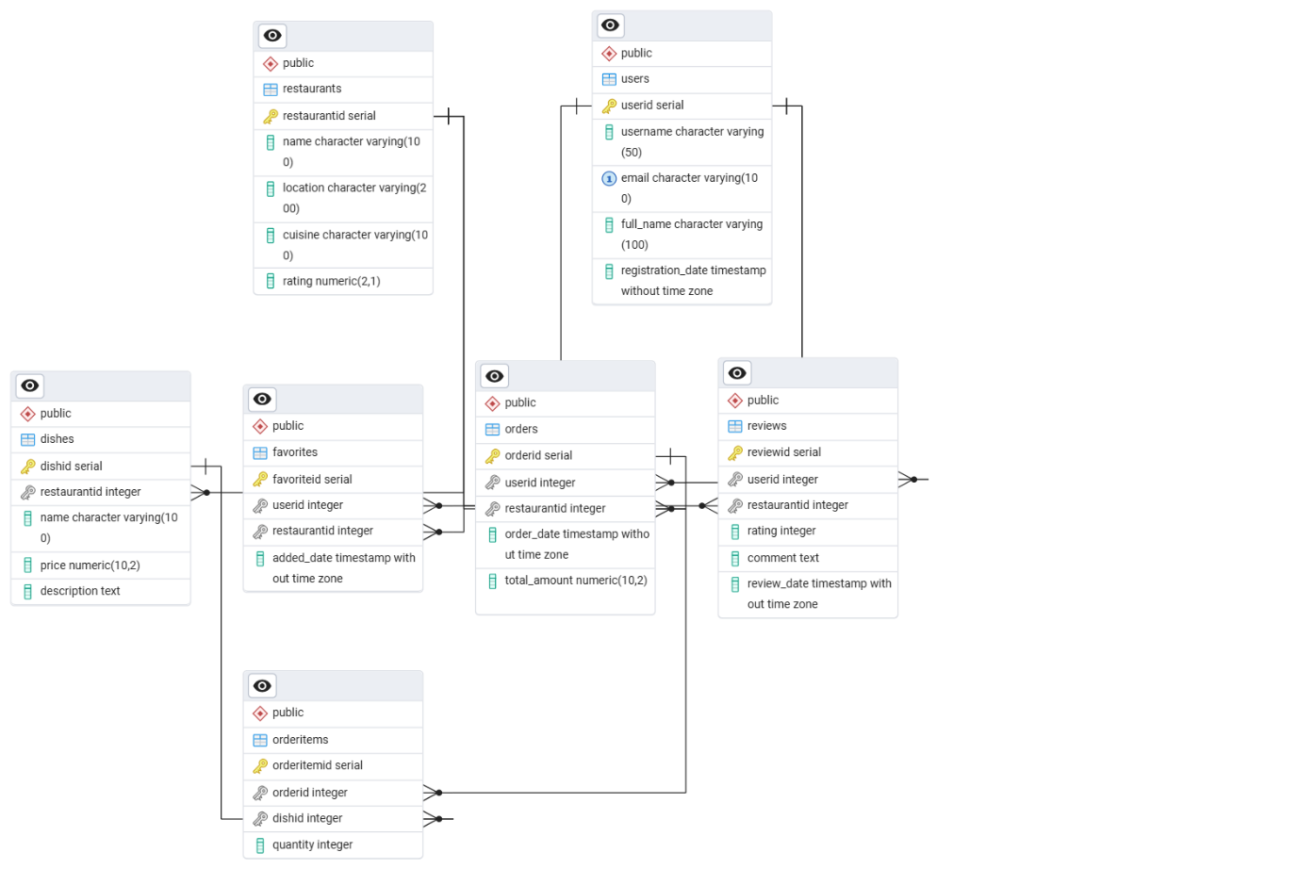

**Conclusion**

In this case study, we explored the schema design and Entity-Relationship diagram of Zomato. As a leading food delivery and restaurant discovery platform, Zomato has transformed the way users explore cuisines, order meals, and share dining experiences. Its structured data model, consisting of entities such as users, restaurants, dishes, reviews, orders, and favorites, ensures smooth interactions between customers, restaurants, and the platform itself. By examining this schema, we gain an understanding of how Zomato efficiently manages restaurant information, customer preferences, and order processing, contributing to its success in creating a seamless and engaging food ecosystem that continues to shape the dining industry.